PROPERTIES OF PARTICULATE SOLIDS
Before we can discuss operations for handling and separating fluid/particle systems we must understand the properties of the particles.

3.1 Individual particle characteristics
In your assigned reading is a discussion on the characterization of particles. The way that we characterize the particles largely depends on the technique used to measure them.
The way that we measure a particle size is as important as the value of the measured size. For example, how would you quantify yourself if measured by
- 1. Circumference around your waist?
- 2. Diameter of a sphere of the same displacement volume as your body?
- 3. Length of your longest chord (height)?

As you can deduce, the measured values have different meanings and will be important relative to those meanings. If you are sizing a life jacket belt you would interested in the first size. If you are buying a sleeping bag I suggest the last one.
Based on the measurement techniques the particle sizes are typically related to equivalent sphere diameters by
- a. The sphere of the same volume of the particle.
- b. The sphere of the same surface area as the particle.
- c. The sphere of the same surface area per unit volume.
- d. The sphere of the same area when projected on a plane normal to the direction of motion.
- e. The sphere of the same projected area as viewed from above when lying in a position of maximum stability (as with a microscope).
- f. The sphere which will just pass through the same size of square aperture as the particle (as on a screen).
- g. The sphere with the same settling velocity as the particle in a specified fluid.

There are two other methods that I know of for sizing particles that are not based upon comparison to a standard (sphere) shape.
- a. The first method is to fit the particle area projected shape to a polynomial type of relation. The values of the polynomial coefficients characterize the particle shape.
- b. The second method is through the use of Fractals. A fractal length can be determined which characterizes the size of the particle and its dimensionality somewhere between linear and two-dimensional.

We will not be spending any time with these latter two methods though they would be interesting topics for a term paper.
Probably among the earliest forms of particle classification (sizing) to be developed is sieving. Several sieve standards exist which classify particles according to the size hole through which the particles can pass. “Filtration Spectrum” which compares, among other things, the relative sizes of common materials.
Except for the extreme case of long thin fibers, the particle mean size will be of the same order of magnitude of the dimensions of the particle no matter which method is used.
There are a number of properties of particles that are of interest besides its size and shape. Particles can repel or attract each other due to static charge build up, they are affected by van der Waals forces (when they are small enough), they can stick, agglomerate, break up, bounce off of each other, chemically react with each other, and they are effected by the surrounding fluid phase due to drag an buoyant forces.

3.2 Measurements
There are a number of methods for measuring particle sizes and size distributions.
Some of these methods depend upon calibration with known particle sizes. A number of suppliers now sell small spherical particles of nearly uniform size distributions for calibration purposes.
Some of the more advanced methods of particle size measurement not only measure the particle sizes but they will also provide the size distributions of the particles. One of the better known instruments for this is the Coulter Counter.
For a given material, there are four types of particle size distributions that are possible: (1) by number, (2) by length, (3) by surface, and (4) by mass (or volume).
Distributions can be reported either in terms of frequency (differential form) or by cumulative (integral form) as shown below.
To explain how we mathematically represent the distribution data, lets suppose that you measure the mass of particles by size by some unspecificed process. As an example your measured data may be plotted as shown in Figure 3-1. You can normalize the plot by dividing the masses of each size by the total mass, to obtain the mass fractions as shown in Figure 3-2.
Finally, if we add the mass fractions cumulatively we get the Cumulative Mass Fraction plot, shown in Figure 3-3.

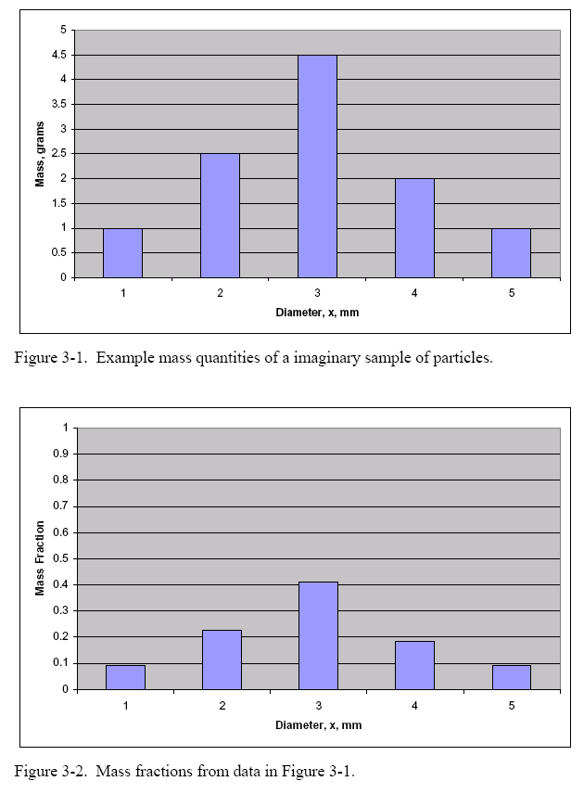

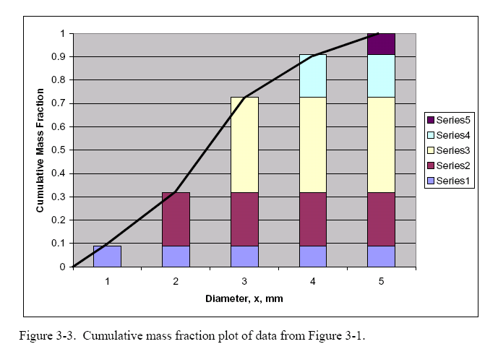

From these Figures we see that the cumulatve mass fraction can be written mathematically as
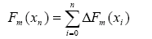 (3-1)
as a function of the n^{th} particle size. Furthermore, we can write the increment in the cumulative mass, as
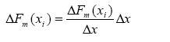 (3-2)
where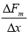 is the slope of the curve on the cumulative mass fraction plot. We define this slope to be the frequency distribution of the mass fraction , where
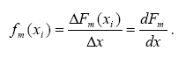. (3-3)

Hence, we can relate the cumulative mass fraction to the frequency distribution by
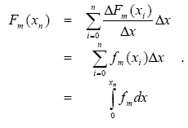. (3-4)
Let the fractional amount of particles of size x be for any type of measurement (by mass, number, area, etc.) be represented as
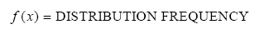 (3-5)
(see L. Svarovsky, Solid-Liquid Separation, 3rd ed., Butterworth, London, 1990, chapter 2). If the particle size distribution is determined as the number fraction then the number frequency distribution is given by
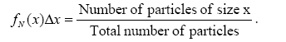. (3-6)
where is the differential range above and below size x that the number count represents. If the particle size distribution is determined on a microscope by measuring projected areas or by laser attenuation then the surface fraction or frequency distribution based on surface area is
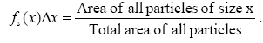. (3-7)
Since f is a fractional amount, then integrating over all particle sizes gives the whole, or
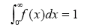 (3-8)
and if we integrate over only the range from zero to some size x we get the cumulative fraction, F(x),
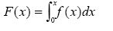 (3-9)
which is the area under the f(x) curve from 0 to x.
Plots of F and f have the general form
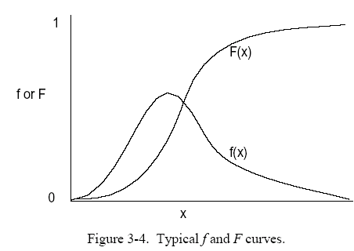

Where, f and F are also related by
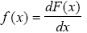 (3-10)
The frequency distributions, f(x), and the cumulative fraction, F(x), may be based on numbers of particles or surface areas as described above, and are denoted with subscripts N or S. Linear and volume (mass) basis for the distributions also exist and are denoted by subscript L or M.
- 1. Number Distribution f_{N}(x)
- 2. Distribution by Length f_{L}(x) (Not used in practice)
- 3. Distribution by Surface f_{S}(x)
- 4. Distribution by Mass f_{M}(x) (Equivalent to distribution by volume)

The several types of distributions are all related to the number distribution by
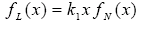 (3-11)
(3-12)
(3-13)
where k₁, k₂, and k₃ are geometric shape factors.
Similarly, the cumulative distributions can be related
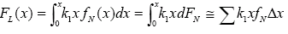 (3-14)
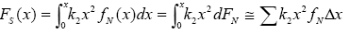 (3-15)
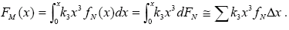. (3-16)

Often, experimental data are reported in discrete form (such as from a sieve analysis). For these data it is easier to work with discrete forms of the integral equations:
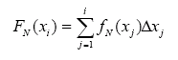 (3-17)
Where 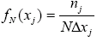 (3-18)
where is the number of particles in the j^{th} set, N is the total number of particles, and .is the size increment range that represents.
As an example, to find k₂, we start with
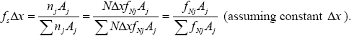
Let, and combine with Eq. (3-12), upon rearrangement we get
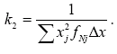
There are several equations that are typically fitted to the distribution. The most widely used function is called the log-normal distribution. It is a two-parameter function that gives a curve, which is skewed to the left compared to the familiar bell curve. This function is normally used because in most cases there are many more measured fine particles than larger particles.
The lognormal function is best described first by considering the normal distribution of the Gaussian (bell shaped) curve shown in Figure 3-5a:
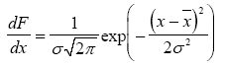 (3-19)
where F is the cumulative undersize fraction of particles, x is the particle size, σ is the standard deviation, and is the mean particle size. To obtain the log-normal distribution, Figure 3-5b, we substitute ln(x) for x and ln(σg) for σ. This gives
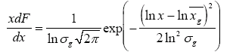 (3-20)

where is the geometric mean and is equal to the median size (where 50% of the particles are greater in size and 50% are smaller in size).
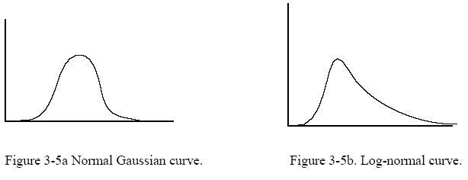
Figure 3-5a Normal Gaussian curve. Figure 3-5b. Log-normal curve.
When Eq.(3-20) is rearranged and the substitution
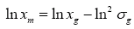 (3-21)
is applied, we get the more convenient form
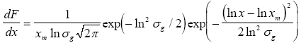(3-22)
in which xm represents the mode because it is the size at which dF/dx has its maximum (recall f(x) = dF/dx, hence f is maximum at its mode, at xm). Svarovsky (L. Svarovsky, Powder Technology, 7, 351-352, 1973) recommends writing Eq. (3-22) as
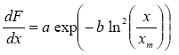 (3-22a)

Where,
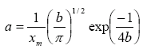 (3-22b)
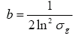 (3-22c)
to simplify the calculations.
Figure 3-6. Comparison between log normal curves with and . Both curves have the same area, but the larger standard deviation causes the second curve to have a smaller peak and more spread.

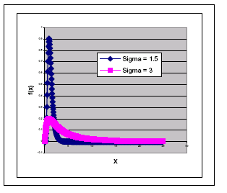

3.3 Choice of Mean Particle Size
As shown in handout 3 and the previous discussions, there is a bewildering number of different definitions of "mean" size for a particle. The choice of the most appropriate mean is vital in most applications.
As can be seen in Figure 3.8, two different size distributions may have the same arithmetic mean, but all of the other means may be different.

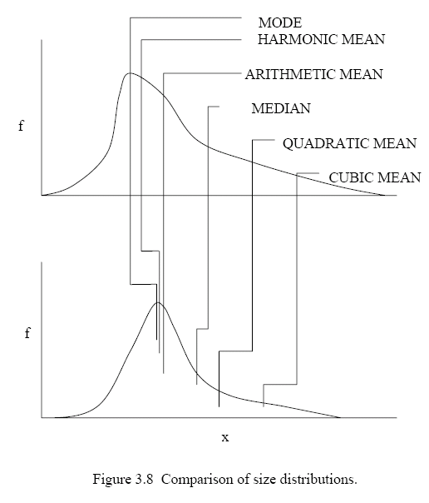

The mode is the x value at which f(x) is a maximum. The median is the x value at which F(x) = 0.50.

The various means are defined by:
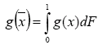 (3-23)
or by the equivalent expressions
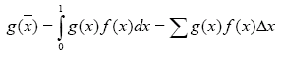 (3-24)

g(x) = | NAME OF MEAN
x | ARITHMETIC MEAN,
x2 | QUADRATIC MEAN,
x3 | CUBIC MEAN,
log x | GEOMETRIC MEAN,
1/x | HARMONIC MEAN,

Example, suppose we want the cubic mean of a set of particles for which we know the number distribution. The mean is defined such that
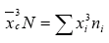,
or
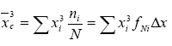
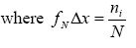
Hence
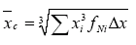
Suppose you have the mass distribution frequency of a set of particles and you want the geometric mean. How would you calculate the geometric mean from the given mass distribution frequency?
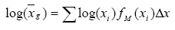
hence

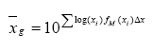
The mean particle size is rarely quoted in isolation. It is usually related to some measurement technique and application and used as a single number to represent the full size distribution. The mean represents the particle size distribution by some property which is vital to the application or process under study. If two size distributions have the same mean (as measured using the same methods) then the behavior of the two materials are likely to behave in the process in the same way.
It is the application therefore which governs the selection of the most appropriate mean. Usually enough is known about a process to identify some fundamentals, which can be used as a starting point. The fundamental relations may be overly simple to describe the process fully, but it is better than randomly selecting mean definition.
EXAMPLE 3-2. Comparison of mass versus number count.
Consider measuring the size distribution by sieving.
Table 3.2 Sieve analysis of a sample of particles. Mass, number, and area fractions are calculated.
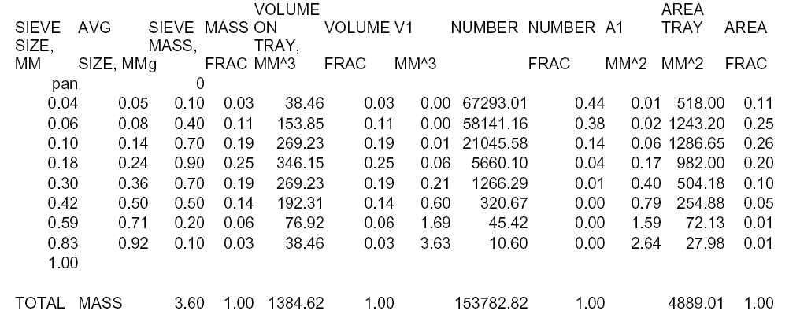

The mass fraction is found simply by dividing the sample masses (sieve mass) by the sum of the masses. Dividing the sample mass by the particle intrinsic density (assumed here to be 2.6 g/cm³) gives the volume of the particles in the sample. Dividing the sample volume by the volume of one particle (4/3πR³) where R is the sieve size opening, gives

the number of particles for that sample. The total surface area of the particles of a given size is obtained by multiplying the number of particles times the surface area of one particle (4). The number and area fractions are found by dividing the sample values by the totals.
The plot in Figure 3.9 shows that the modes of the three distributions vary widely. The number distribution and surface area distribution are skewed greatly to the small particle size. This shows that a small mass of the fines contains a large number of particles.
A property such as turbidity is sensitive to the total number of particles, hence the large number of fines will cause the fluid to be cloudy. A process such as filtration is sensitive to the total surface area of the particles due to the drag resistance to flow across the surface.

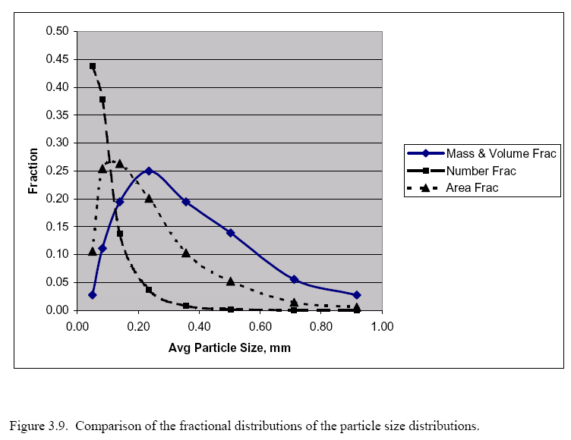

EXAMPLE 3-3. Application: cake filtration, cake washing, dewatering, flow through packed beds and porous media.
If the particle size distribution is known, what definition of the mean should be used?
In flows through a packed bed we can consider the pores to be conduits. We can apply the concept of a friction factor and a Reynolds number. Since the geometry of an arbitrary pore is not cylindrical, we apply the hydraulic radius, Rh.

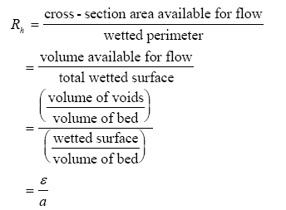(3-25)
where ε is the bed porosity and a is a surface area. This surface area is related to the specific surface area , of the solids (total particle surface/volume of particles) by
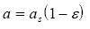 (3-26)
The specific surface area in turn is related to the mean particle diameter (assuming the particle can be represented by a sphere)
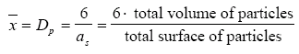 (3-27)

For spheres the total volume of particles is given by
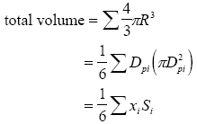 (3-28)
and the total surface area of the particles is given by
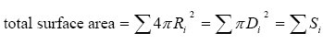 (3-29)
Hence, we get the mean particle diameter to be

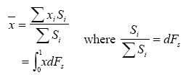 (3-30)
where the latter expression is the analytical formulation.
This latter expression defines the mean to be the arithmetic mean, (from Eq. 3-23) of the distribution by surface.
Next, we must relate this to a size distribution by mass (the usual way of measurement). The surface distributions by surface and mass can be related by
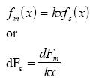 (3-31)
where k is a constant that accounts for the geometric shape of the particles. It is assumed here that k is independent of x.
Since the mean size is given in Eq. (3-30), then combining (3-30) and (3-31) we get
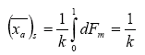 (3-32)
where the integral is unity. If we go back to Eq.3-31, we can integrate to obtain
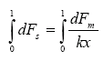 (3-33)
or, since k is not a function of x,
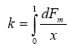 (3-34)
where the RHS of Eq.(3-34) is the definition for the Harmonic mean, 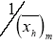 , of the mass distribution given by Eq. (3-23). Hence this shows that the surface arithmetic mean is equal to the mass harmonic mean, 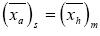 .
Therefore, for flow through packed beds, filter cakes, etc., the appropriate mean particle size definition is the arithmetic average of the surface distribution.

This is shown to be equivalent to the mass distribution harmonic mean.
EXAMPLE: 3-4. Mass recovery of solids in a dynamic separator such as a gravity settling tank.
For a settling process in which mass recovery is to be optimized, which would be the most appropriate mean particle size?
Total recovery of any separator can be obtained by combining the feed size cumulative distribution, F(x), with the operating grade efficiency curve, G(x). Mathematically, this is written as
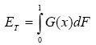 (3-35)
where Et is the recovery by mass.
A simple plug flow model of the separation in a settling tank without flocculation gives the grade efficiency in the form
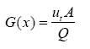 (3-36)
where A is the settling area, Q is the suspension flow rate, and ut is the terminal velocity of particle size x.
Assuming Stoke's law for the terminal velocity
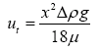 (3-37)
then these three equations can be combined to obtain
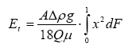 (3-38)
where the integral defines the quadratic mean of the particle size distribution by mass. We will discuss Grade efficiency in further detail in a later section when we discuss about separation process.

